High-Level Functional Requirements Specification
Project: Jalrekha and PHED – Single Village Scheme (SVS) and GHAN 2.0 Integration
Department: Public Health Engineering (PHE), Government of Madhya Pradesh

1. Purpose and Scope
This document defines, at a high level, the functional requirements for extending the Jalrekha platform to PHE for Single Village Schemes (SVS), and for integrating it with GHAN 2.0. It covers seven functional modules and the integration layer, with an indicative development timeline.
In scope: role-based user management, asset mapping, data visualisation, tap connection validation (Parinam), meter reading (Dhara), water quality testing (Nirmal), community participation (Sahbhagita), Jal Samadhan, and GHAN 2.0 integration.
Integration:
- GHAN 2.0 integration with Jal Rekha (at both Mobile and Web) :- GHAN 2.0 has different technology stack which need to be redirected and bring all modules on same technology stack of Jal Rekha. (for now we will redirect from jal Rekha to GHAN app)
- Jal Rekha has 2 login where Jal rekha department login and other PHE department login. And where PHE will have 2 user login of PHE SVS and GHAN user.
- AI Integration :- FHTC Parinam Tap connection module developed in Jal Rekha AI features can be used in SVS PHE and GHAN module integration.

2. Stakeholders and User Roles
Role | Description | Access
EE (Executive Engineer) | Administers schemes and users | Web
AE | Monitoring and supervision | Web and Mobile
SE | Field-level supervision, asset and validation review | Web and Mobile
TPIA/ TL | Third-party inspection agency staff and team leads | Web
ISA | Implementation Support Agency (Sahbhagita module) | Web and Mobile

3. Assumptions and Dependencies
- The department provides the User Master and Scheme Master before development of Module.
- The department provides the scheme-wise ISA list for Sahbhagita.
- Dhara mobile meter reading applies only where water meters are installed.
- Timelines are in working days of development effort, exclude department-side delays in data or approvals, and exclude UAT.

4. Functional Requirements
Divided into Below Mentioned Modules & Estimated Timeline

4.1 User Management Module on Web (15 days)
- User registration
- Role-based login for EE, AE, SE, TPI-A and TPI-TL with role-appropriate access (EE: web; AE/SE: web and mobile; TPI-A/TPI-TL: mobile).
- EE can assign schemes to users.
- EE can create users, and activate or deactivate them.
- Role-based menus, dashboards and data visibility (scheme, block, district, division).
- Import of User Master and Scheme Master supplied by the department.
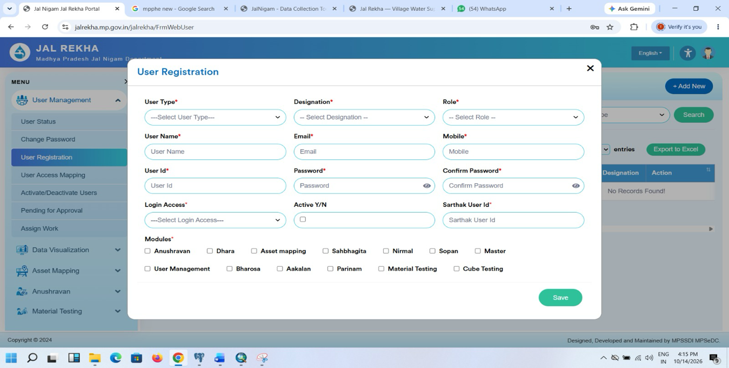
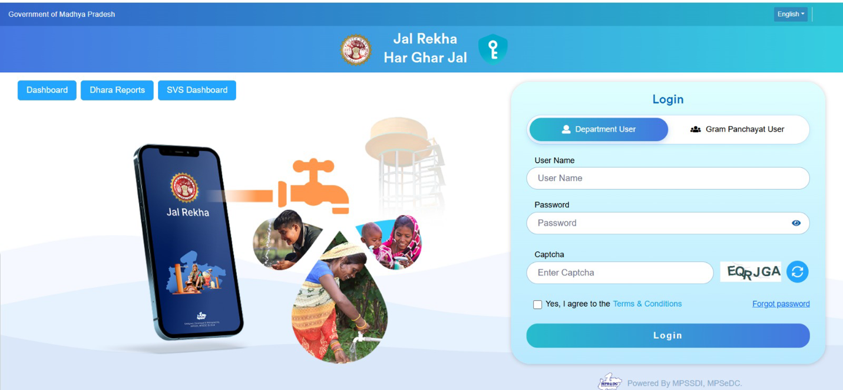
- Audit log of user creation, status changes and scheme assignments.
PHE

4.2 Asset Mapping Module (15 days)
- Display and maintain already-mapped assets: distribution pipeline, OHT (overhead tank) and tubewell.
- Enable mapping of pending assets: sump well and pump line.
- Assets upload facility in web portal
- Capture asset geo-location and attributes through the mobile app.
- Link every asset to its scheme and village.
- Asset mapping report (scheme-wise, district-wise, status-wise: mapped vs pending) on the web application, with export.

4.3 Data Visualisation (10 days)
- Scheme-wise visualisation of SVS asset data.
- District-wise visualisation of SVS asset data.
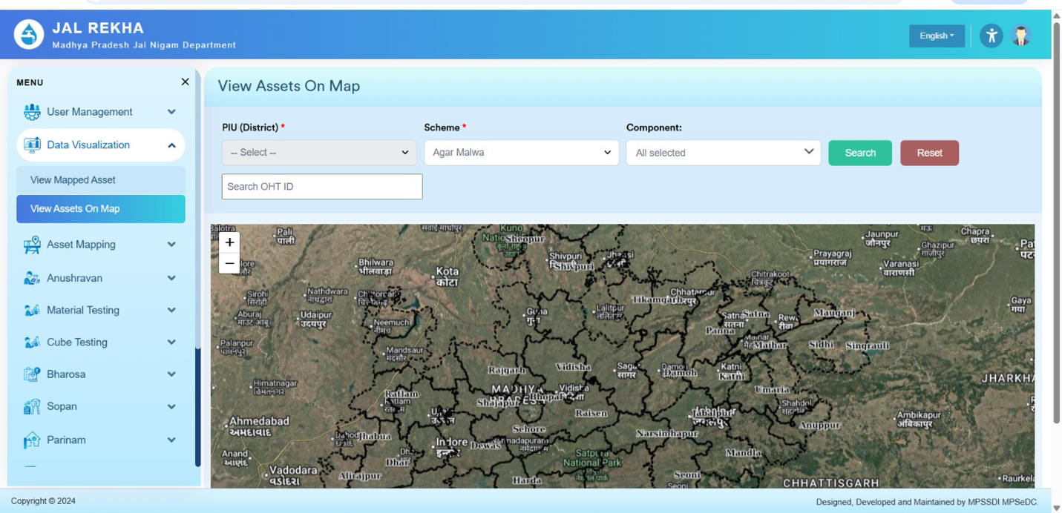
- Map and chart views with drill-down from district to scheme to asset.

4.4 Parinam Module – Tap Connection Validation (15 days)
- Mobile app function to validate household tap connections in the field and integration with AI.
- Integration with Samagra ID for beneficiary/user identification.
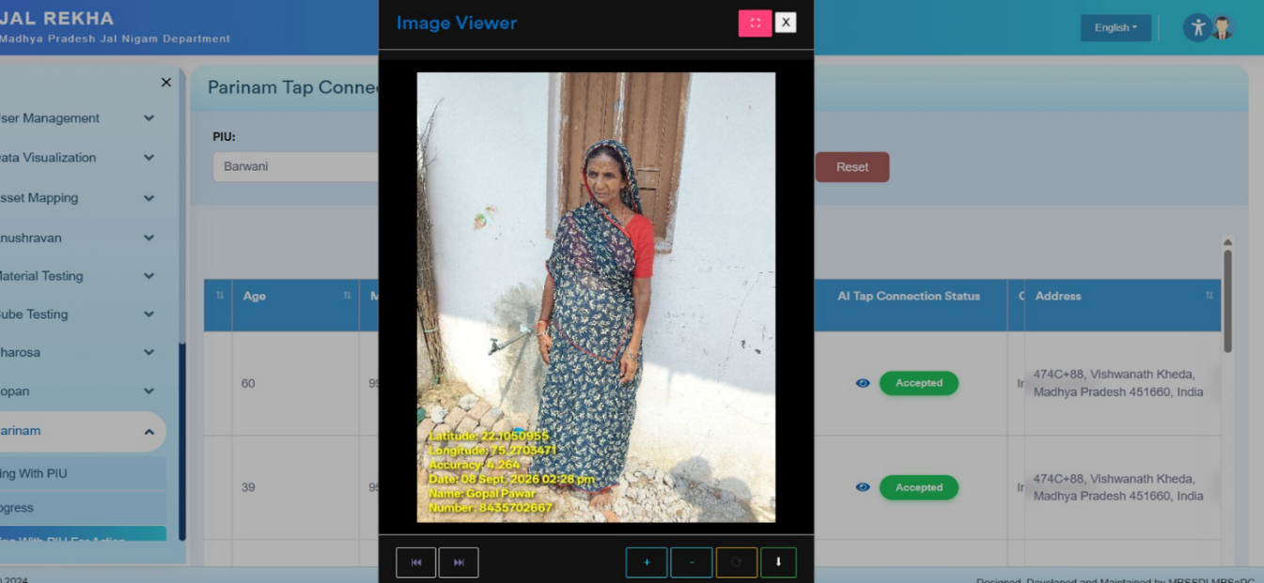
Web module for report of validation status (validated, pending, not found) by scheme, village and district.

4.5 Dhara Module – Water Quantity (18 days)
- Make the existing Jalrekha web module for PHE available to PHE users (role-based).
- Mobile app for meter reading where a water meter is available (reading entry, photo capture, geo-tag, timestamp).
- Validation of readings (for example, a reading lower than the previous one is flagged).
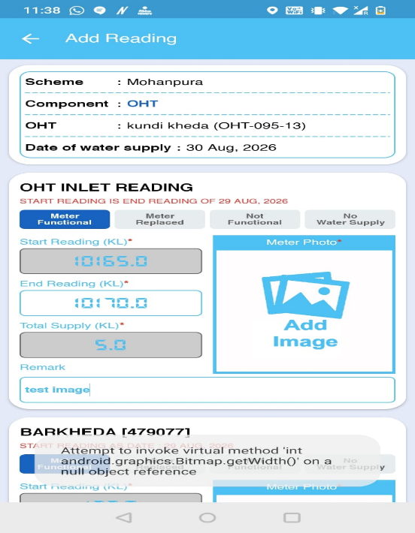
- Web reports on consumption and reading status.

4.6 Nirmal Module – Water Quality (15 days)
- Make the existing web module for water sample testing available to PHE users.
- Mobile app for geofenced sample collection from assets (collection allowed only within a defined radius of the asset).
- Mobile app for sample collection from OHT ,Tubewell and Beneficiaries.
- Record sample details, test results and status; flag results that fall outside permissible limits.
- Web reports .
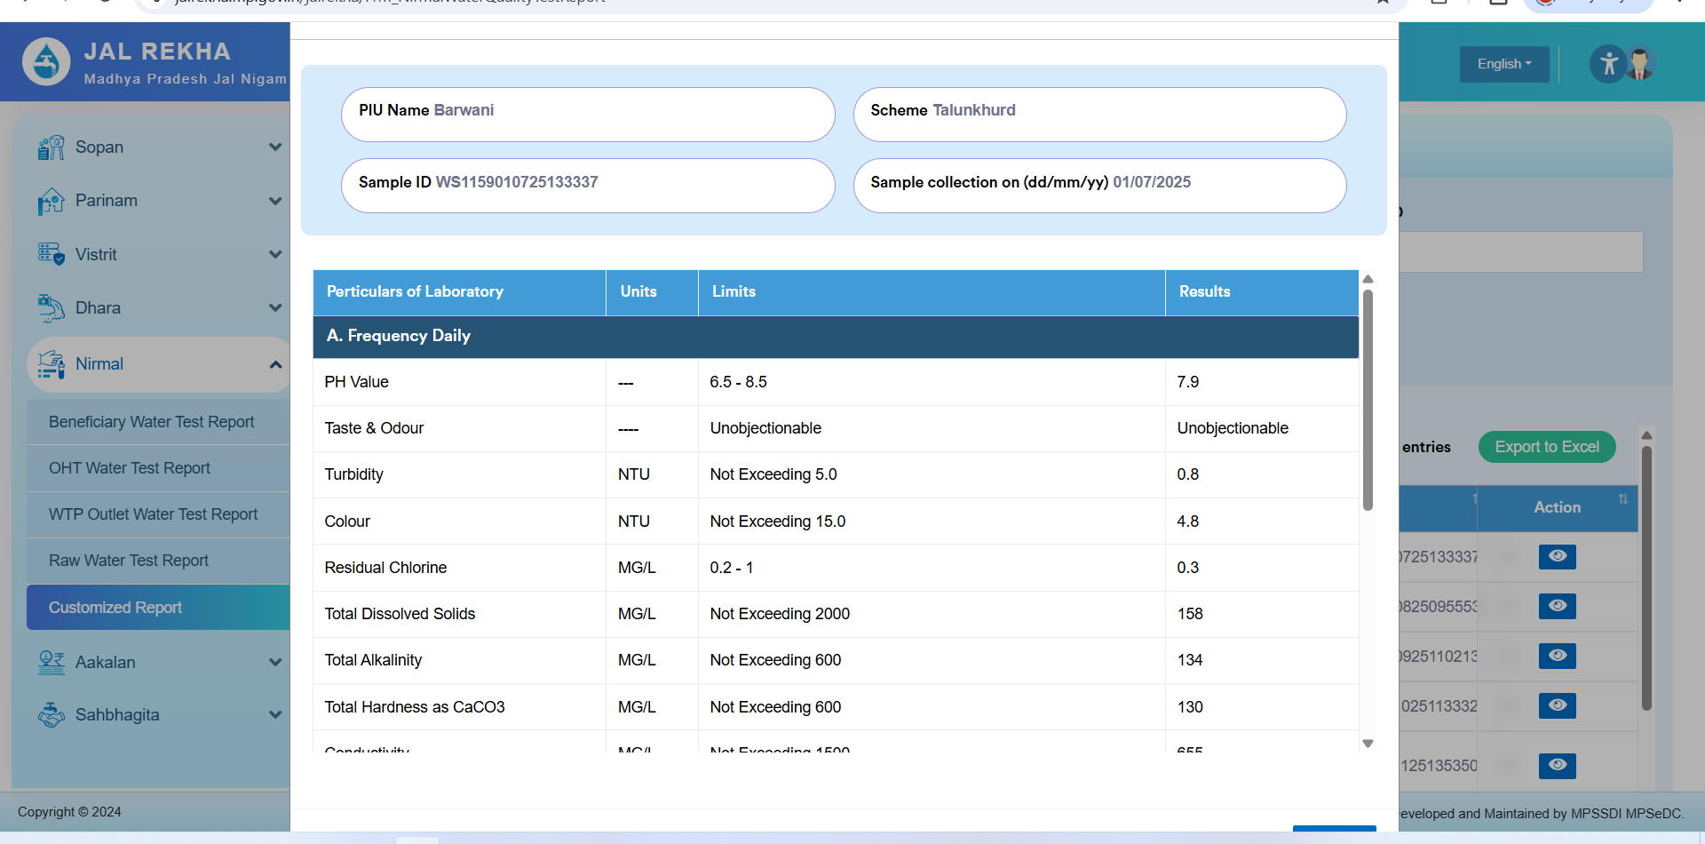

4.7 Sahbhagita Module – Community Participation (15 days)
- Web and mobile modules for community participation activities.
- Scheme-wise mapping of ISAs using the list provided by the department.
- Activity capture, monitoring and reports by ISA, scheme and district.

4.8 Jal Samadhan – Unified Complaint and Grievance Module
Jal Samadhan is incorporated into Jal Rekha as the single module for raising and tracking complaints for Handpumps, SVS and MVS.
Complaint registration
- Citizen registration and OTP-based login.
- Complaint categories for Handpump (not working, low discharge, contaminated water, damaged platform), SVS and MVS (no supply, low pressure, pipeline leakage, quality issue, meter issue, others).
- Asset selection by map, asset ID or nearest-asset search; geo-tagged photo upload; location capture.
- Unique complaint ID generated for every complaint, whichever channel it comes from.
Processing and tracking
- Automatic routing to the responsible officer or team based on asset type, scheme and location. Handpump and SVS complaints go to PHED field functionaries; MVS complaints go to MPJN-designated officers.
- Assignment to technicians or field staff, with status updates, before and after geo-tagged photos, and maintenance or repair details.
- Real-time status tracking for the citizen, with SMS or WhatsApp notifications at registration, assignment and closure.
- Citizen feedback on closure, with the option to reopen a complaint.
Escalation and monitoring
- Time-bound, level-wise escalation as described in Section 9.
- Dashboards for the ACS, MPJN, Engineers-in-Chief, SE, EE and AE covering complaints received, pending, resolved, escalated and breaching the timeline.

Reports by district, scheme, asset type, channel, category and officer; export to Excel and PDF.

4.9 GHAN 2.0 Integration (12 days)
- GHAN 2.0 web portal integration
- GHAN 2.0 mobile app integration with jalrekha app.

5. Indicative Timeline
Effort summary (working days):
# | Module | Effort (days)
1 | User Management | 15
2 | Asset Mapping | 15
3 | Data Visualisation | 10
4 | Parinam | 15
5 | Dhara | 18
6 | Nirmal | 15
7 | Sahbhagita | 15
8 | Jal Samadhan | 20
9 | GHAN 2.0 Integration | 12
 | Total effort | 135

Phase-1 | Phase-2
User Management | Asset Mapping
Parinam | Data Visualisation
Dhara | Nirmal
Sahbhagita ,Jal Samadhan | GHAN 2.0 Integration starts as Nirmal completes)
UAT, bug fixing and department feedback | UAT, bug fixing and department feedback
Go-live preparation, training, deployment | Go-live preparation, training, deployment

